Noon Academy

**Noon Academy, a Project of CityNet Co. Ltd**

**Malaz Riyadh**

**PHONE: 00966 14799998**

**FAX: 00966 12065255**

**2/11/2013**

By Kifayat Ullah Khan

Noon Academy is an online tuition and training center in which you can get live interactive sessions with Experts, Teachers and professors on different offered courses. Noon Academy will facilitate the school and university students to master any of their school’s or College’s subject or get Short Training courses from experienced teachers and skilled professionals.

Contents

Introduction 2

1. Home Page 3

2. Available Courses List 4

3. Login Page 5

4. Student Control Panel 6

5. Navigational Menus 7

6. User Profile 8

7. Change Your Password 9

8. Student Control Panel Available Courses List 10

9. Student Enrolled My Courses List 11

10. Student Classes List 12

11. Start of Virtual Class 13

# Introduction

Noon Academy is an online academy providing distance learning facilities and virtual class rooms. We facilitate the distance learning using online means with interactive live session between the teachers and students. We us Internet is a mean for spreading education and facilitating students who are studying in different schools and colleges to have high skilled teacher to teach them any courses or subjects in which they might need extra lessons to master it thoroughly.

In Noon Academy we have the best teaching staff from the local and international schools, colleges and universities. This teaching staff will provide online coaching classes or trainings to the students who are interested in those lessons. It is like you have the best subject specialist teaching to you in your home, using the online virtual class room. You may be joined by other online class fellows so cross questioning of other students will also help you develop more skills in the subject.

To get benefit of the online virtual class room, you can simple register an account on our web site at [www.noonacademy.com](http://www.noonacademy.com) and get started. Choose any courses in which you are interested, and get yourself enrolled to it, after paying the nominal tuition fee your name will be added automatically to the live classes of that specific subject course and you will be able to attend any of the scheduled class. Note that all these classes are live sessions of the course with a real expert teacher and hence give you the facility to interact with the teacher, ask questions, share views, download recorded classes, or library material in the form of e-books etc.

Following are some of the key features that you will find in the online Noon Academy:

1. Online Education with ease of access
2. High Qualified Teachers
3. Home Based Tuition using our Virtual Class Rooms.
4. Download recorded Lecturers and training lessons at any time.
5. Easy Registration process
6. Very affordable and nominal fee structure.

You can also find video trainings on how to use our online learning system on our YouTube channel (<http://www.youtube.com/noonacademysa> ). You can also follow us on twitter and Facebook using our official channel.

A brief introduction with relevant screen shots has been shown below, which will give you clear idea on how to use the application and get yourself ready for your next virtual classes her at Noon Academy.

# 1. Home Page

This is the home page of the web site, with related links to pages and sub pages so you can easily navigate throgh them and get yourself educated in the courses that we are offering for you.

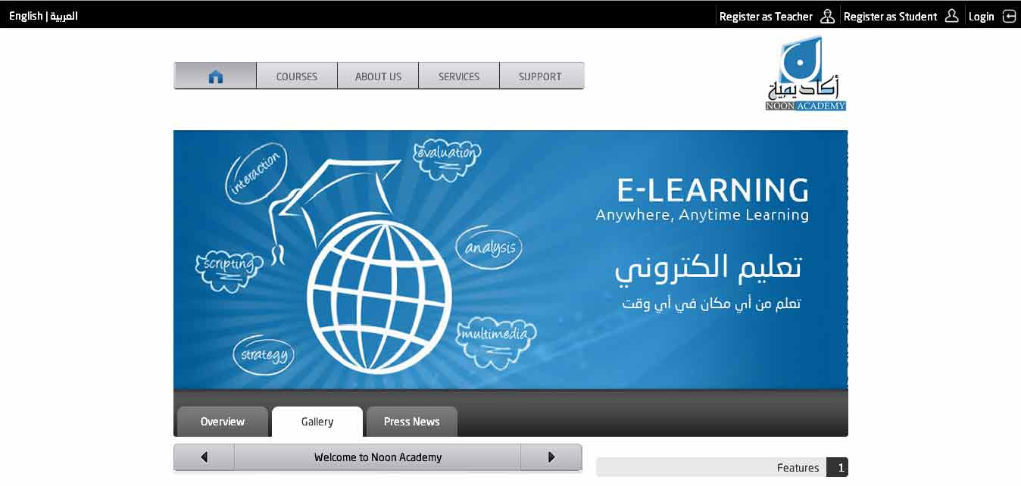

The Home page has links the top of the page for user account registration and login. We offer two different types of user account registrations:

1. Student Registration
2. Teacher Registration

As these names are self-explanatory, you will be interested to register your account as a student. Once you have successfully registered with us as a student you can enrolled to any course that we are offering.

# 2. Available Courses List

The available courses list page shows you any of the courses in any subject that are currently available for student enrollment. You can download the PDF course contents and enroll to the course from this page.

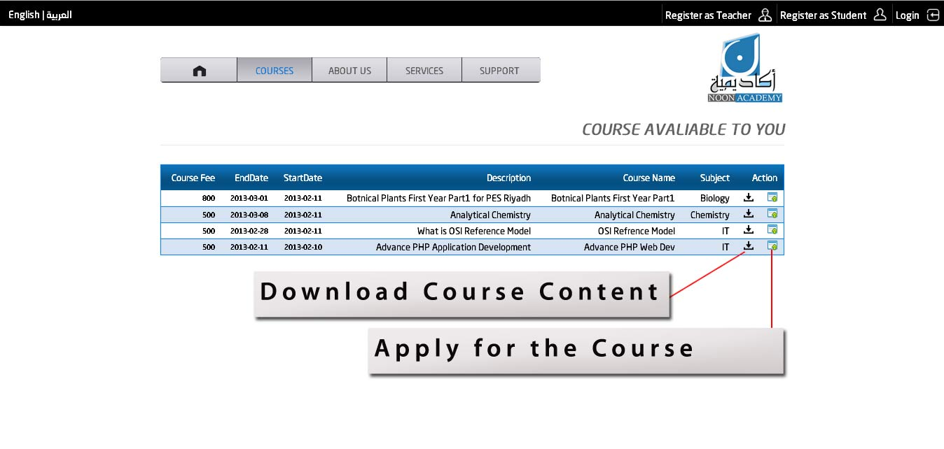

This page is also visible to any guest visitor to the web site without registration or login but if you want to apply to it, you will need to have a student user account.

# 3. Login Page

The Login page is used to provide application access for teachers and students to access their control panel and perform different activities such as join a course, attend a virtual class etc.

The same login page is used for both the student and teachers, and the system can automatically identify the user type from here username.

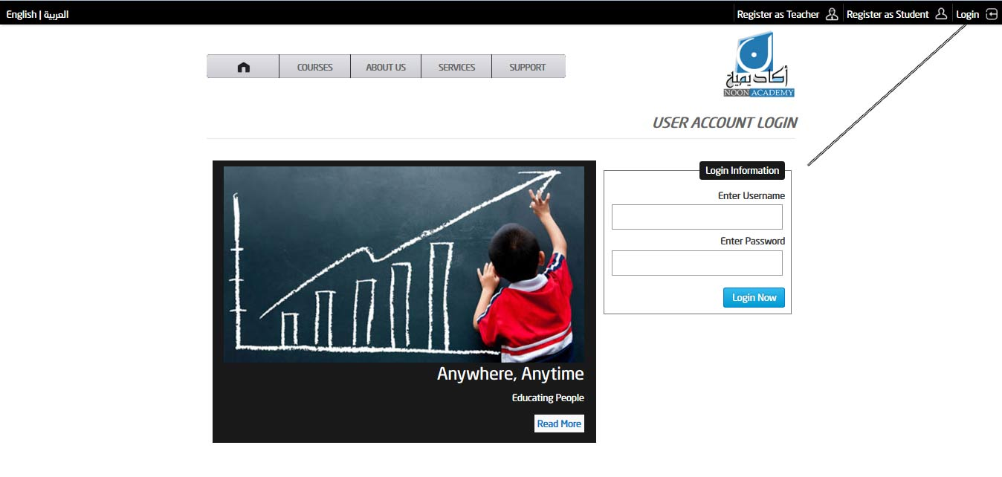

The Username and password can be chosen from the student registration page. Each student has a unique username which could be used to identify every individual student to the system and show him only relevant information based on his selections and choice.

# 4. **Student Control Panel**

Student Control Panel (cPanel) is a one point ease of access dashboard where a student can perform certain tasks. When the student login with his username and password he gains access to this control panel, where he can update in profile information, view the list of available courses and apply for any course he may want.

After enrolling for any course the student is required to pay the tuition fee using any of the payment methods what we offer.

Once the payment is cleared your name will be automatically enrolled to the classes of the selected paid courses, and hence you will be able to attend those classes as per schedule.

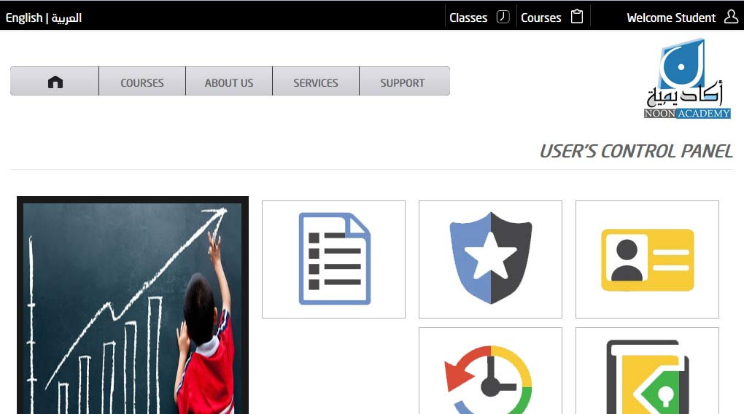

# 5. Navigational Menus

The control panel has both the navigational menus and the Category Tiles which provide the selection of the desired page you may want to navigate. The Top Navigation menu is a drop down menu and you will be required to hover mouse on any of the top menu item in order to make the sub menu become visible.

To navigate to any page just click on the navigation link and the desired page will be loaded. You can form all the authorized actions using the navigation menu.

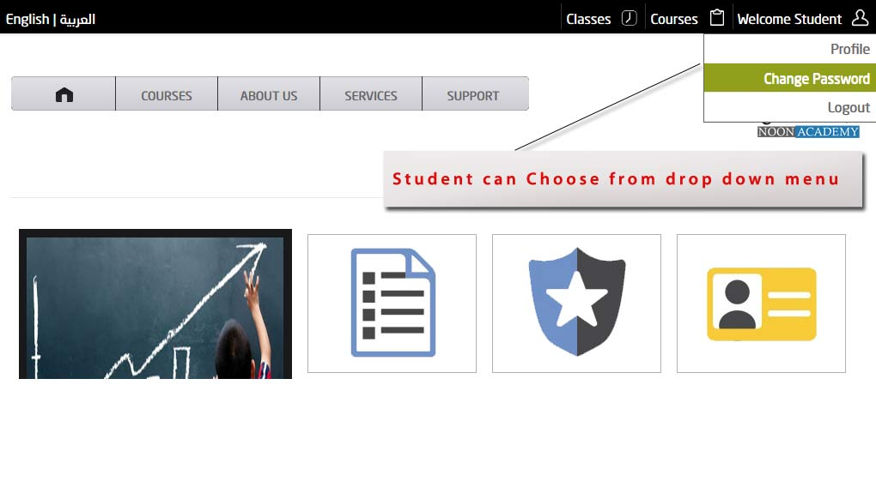

# 6. User Profile

The User profile can be easily access from the top navigation bar, and hence the user can view/update his personal information such as his name, email, phone, address, etc.

This page also provides the facility to upload your image, so that you can personalize the looks and feels of the user account itself.

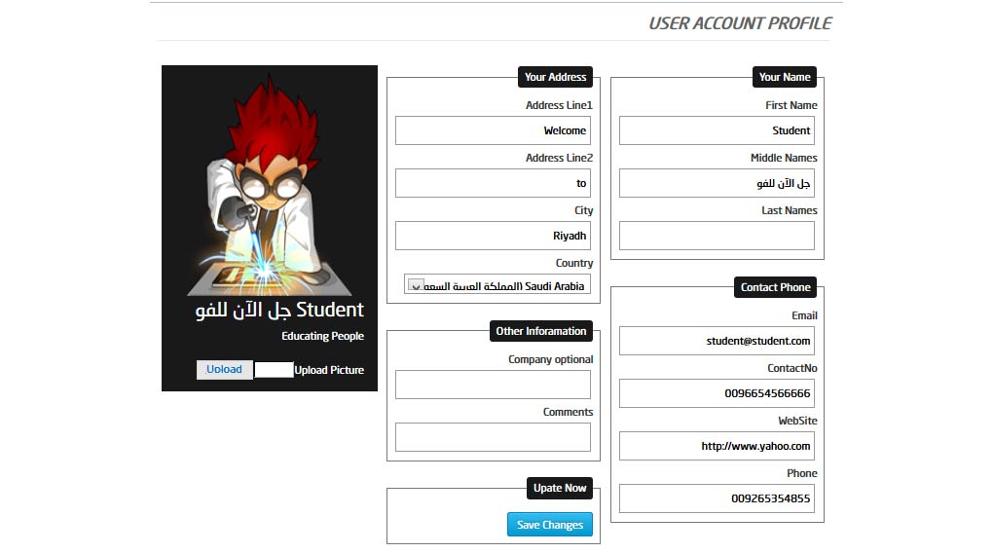

# 7. Change Your Password

We recommend that you must change your password periodically and keep it secret and secure as this is very important to you, and the system identifies you with these credentials. Try to use hard to guess passwords, and if possible make them a combination of mix letter and characters etc. Never use your name, car registration number or any other personal information that your friends and colleagues might know about you, in order to minimized the risk of your password being stolen are miss used.

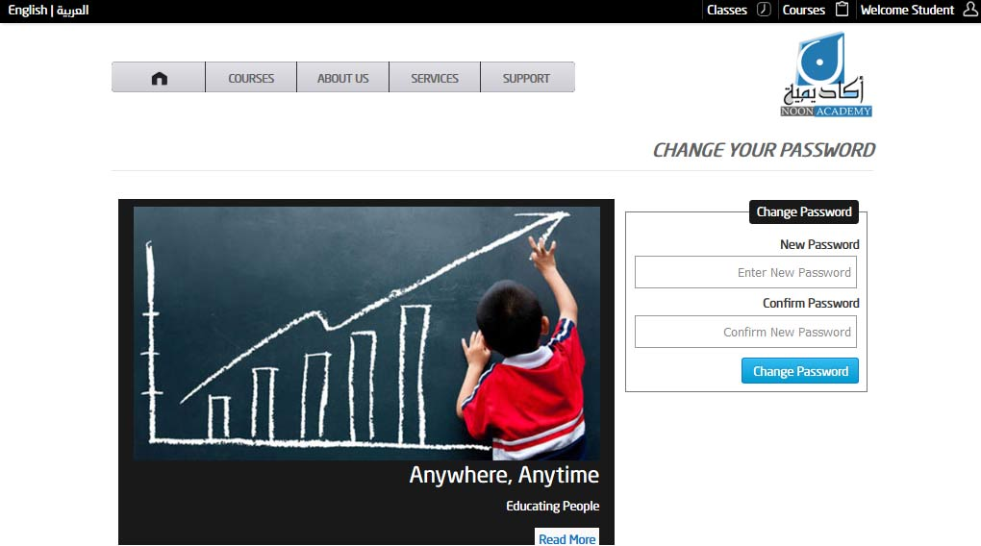

# 8. Student Control Panel Available Courses List

We will be offering courses and training session on Noon Academy from time to time, and all these courses will automatically appear on this page so that you can view them, choose them and possibly enroll yourself to them.

You can also download the courses content in PDF or Word format by click the download icon in the available courses list.

Note that when you enroll yourself to any of the course or training session you will be required to pay the tuition fee to noon academy by any of its available payment channels.

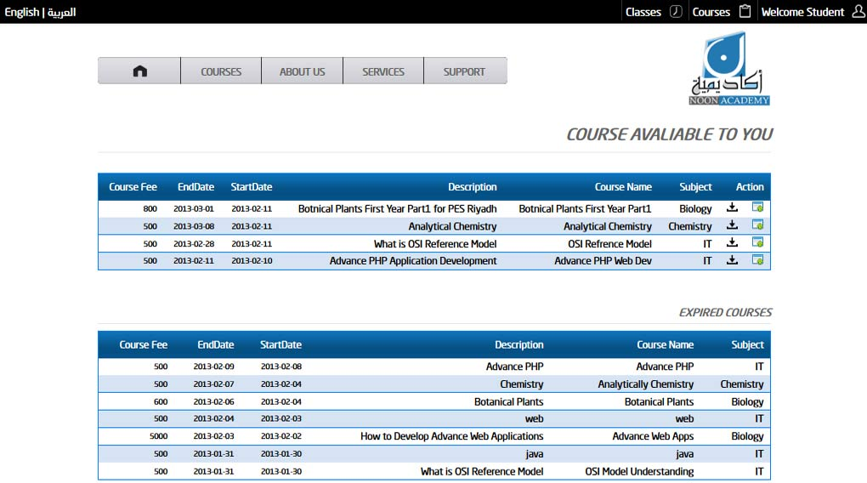

# 9. Student Enrolled My Courses List

When you enroll yourself to any course you can easily view the list of courses that you are enrolled, and also the list of enrolled course for which Noon Academy has already received your payments. In any un paid course you will not be able to attend any class until it has been paid by you.

There might be a case when Noon Academy will offer free courses, which might be on first come first serve bases, if you enrolled to any free course they will automatically be paid for you. And you will be enrolled to attend the classes if the seats are available.

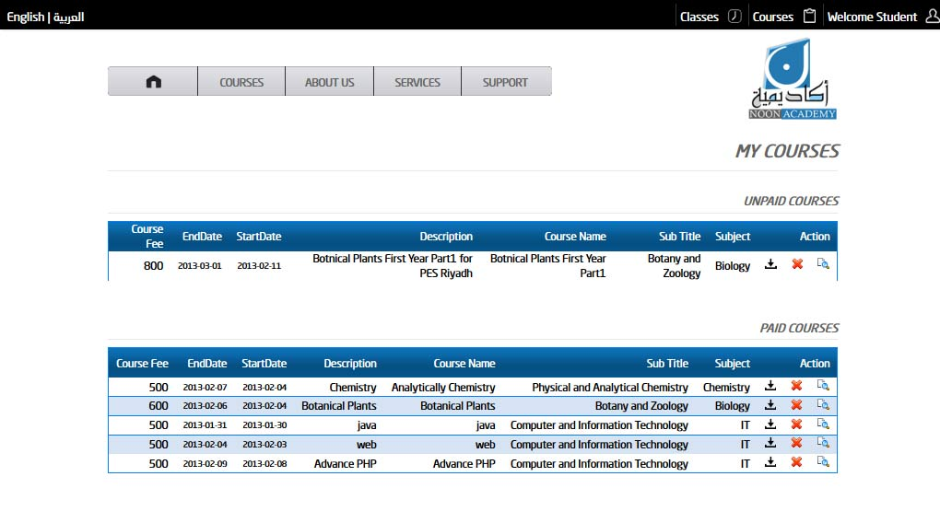

# 10. Student Classes List

When you pay for any enrolled courses the system add you automatically to the virtual classes available for those courses as per schedule. You will see a list of all available classes in which you can participate as a student.

You will also see a list of classes that has been expired and are no longer accessible.

Also not that you can start only one session of a virtual class and no two or more simultaneous classes can be attended from your account for the same course.

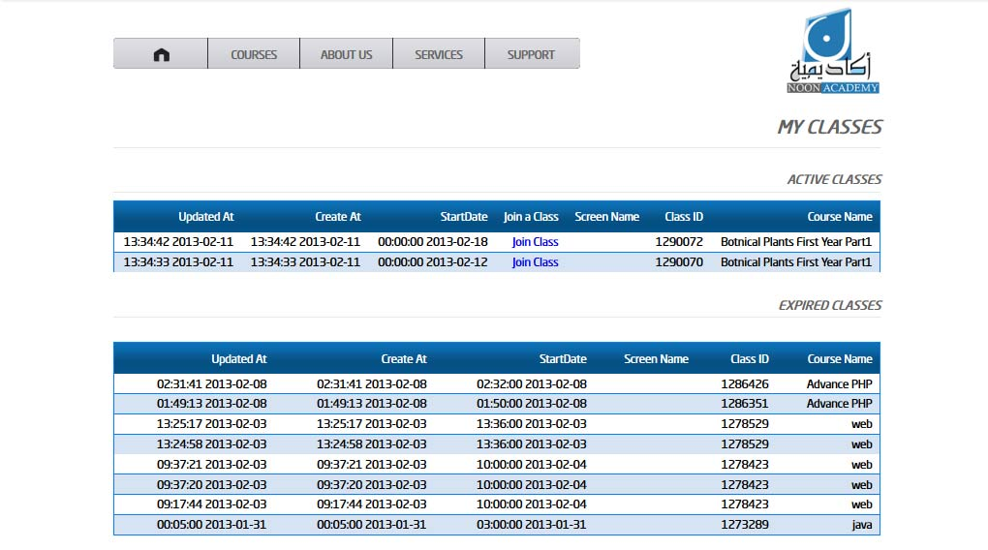

# 11. Start of Virtual Class

When you click on the Join Class Link the classes’ list page, your web browser will open a new page shown as below; this is the virtual classes application through you can attend the class being held. A snapshot of the virtual class is shown below in which you can see the teacher taking a class and the students attending it.

